**Course Project   
DeVry University  
College of Engineering and Information Sciences**

**Project Report**

**Course Number: CIS407A**

**Name: Molly Saling**

This web application was built using Microsoft Visual Studio ASP.NET Core. I made this to keep track inventory of ice cream at an ice cream shop called **Molly’s Homemade Ice Cream**. There are different flavors of ice cream to keep track using productid, ProductName, Inventory, and Price. The business can add, delete, and edit products from the database as needed. All inventory is kept in a database called “product” it was built using **add-migration Initial** then **update-database** was used to finish the database. The color theme is called Minty, it was downloaded from bootswatch. Below you will find screen captures of the home page, product list, edit page, delete page, and the error messages displayed when product information is not filled out.

**Home Page**

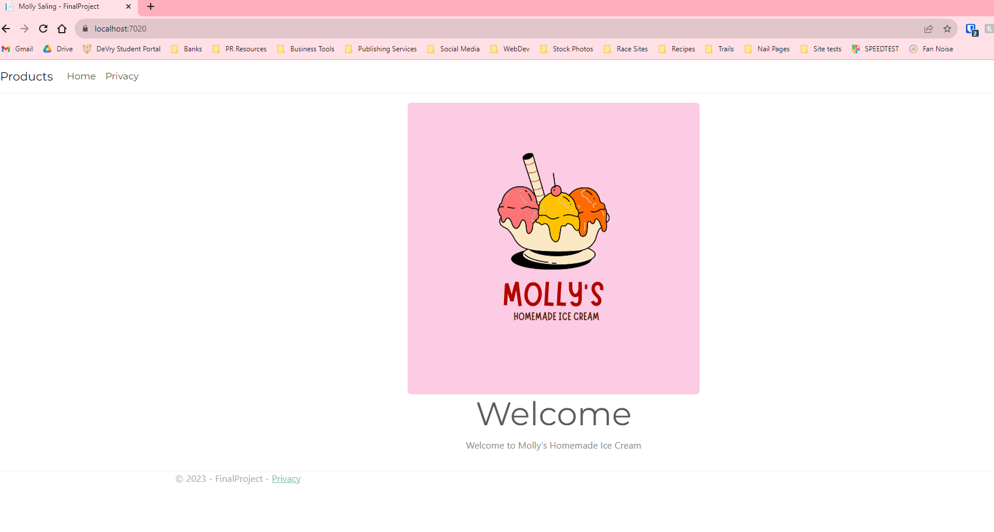

**Edit Page**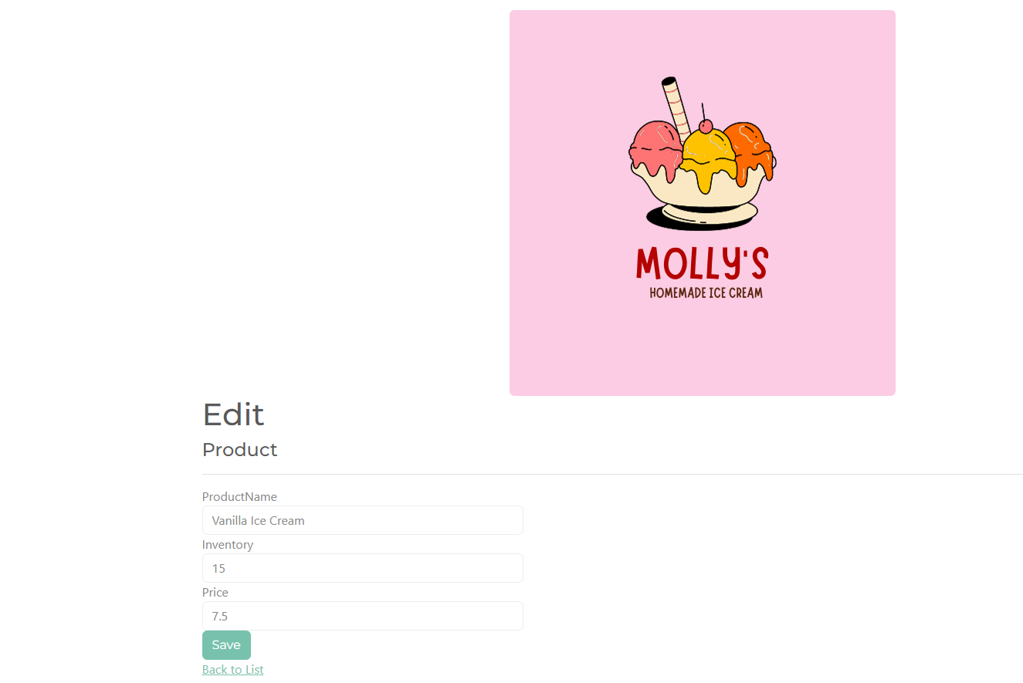

**Product List** 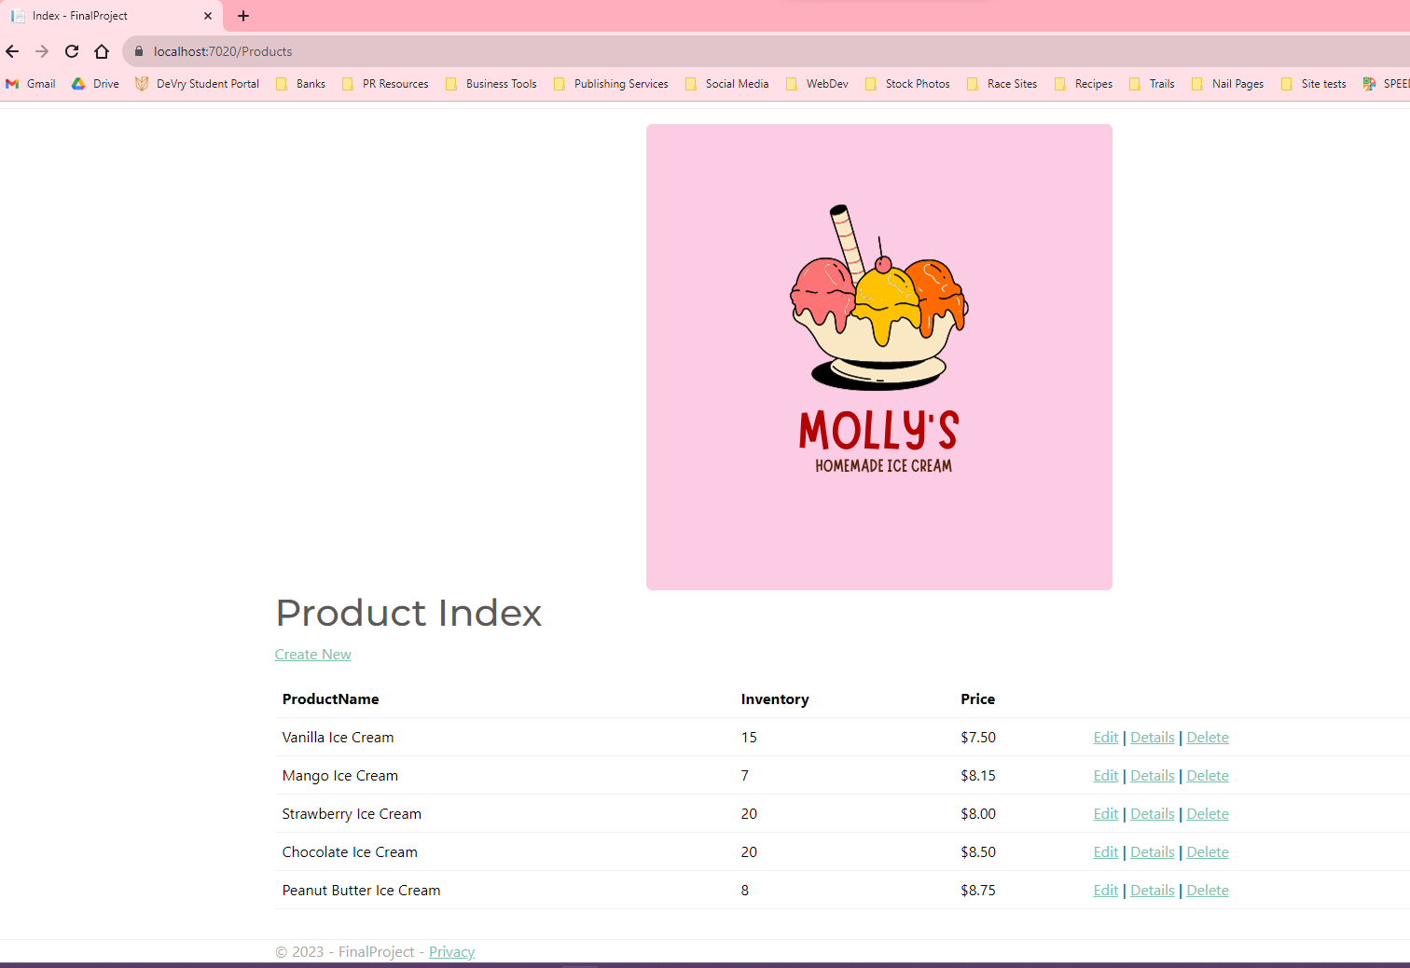

**Delete a product**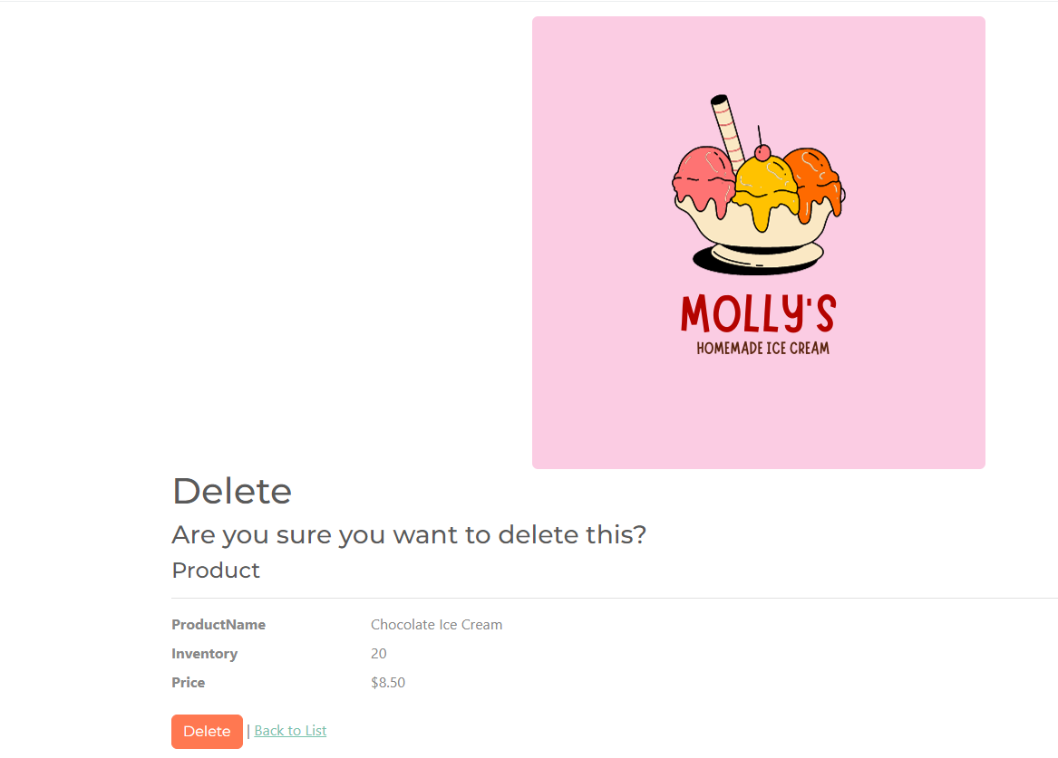

**Error when trying to create a product**